 | Testing and Training Center of Farm Machinery  Department of Farm Machinery and Power Engineering  College of Agricultural Engineering and Technology  Junagadh Agricultural University  JUNAGADH – 362 001 (GUJARAT) | 
P | Phone : (0285) 2672080-90, Ext. 390 & 484; Fax : (0285) 2671018

SPECIFICATION SHEET OF TRACTOR OPERATED DISC HARROW

1.0 | General | :
 | Name of machine | :
 | Name and address of manufacturer | :
 | Name and address of applicant | :
 | Selling price in India | :

2.1 | Gang frame:
 | a) |  | Type and material |  | :
 | b) |  | Size of angle section, mm |  | :
 |  |  | Left gang
 |  |  | Length |  | :
 |  |  | Width |  | :
 |  |  | Right gang
 |  |  | Length |  | :
 |  |  | Width |  | :
2.2 | Weight box::
 | a) |  | Type and material
 | b) |  | Number
 | c) |  | Size of scrapper (mm)
 | d) |  | Location
 | e) |  | Method of fixing
 | f) |  | Adjustment
2.3 |  | Scraper assembly:
 |  | a) | Type and material | :
 |  | b) | Number | :
 |  | c) | Size of scrapper (mm) | :
 |  | d) | Location | :
 |  | e) | Method of fixing | :
 |  | f) | Adjustment | :
2.4 | Gang shaft:
 | a) |  | Type and material |  | :
 | b) |  | Length of shaft (mm) |  | :
 | c) |  | Dia. of shaft (mm) |  | :
 | d) |  | Length of threaded portion (mm) |  | :
 | e) |  | Dia. of threaded portion (mm) |  | :
2.5 | Disc gang:
 | a) |  | Number | :
 | b) |  | No. & type of disc in each gang | :
 | c) |  | Bearings | :
 | d) |  | Method of mounting of each disc | :
 | e) |  | Size of bolt (mm)
 |  |  | Length | :
 |  |  | Dia. | :
 |  |  | Pitch | :
 | f) |  | Method of changing the gang angle | :
 | g) |  | method of fixing one gang frame to another | :
2.6 |  | Gang angle:
 |  | a) | Angle made between axis of the gang and the line perpendicular to the direction of motion (deg.) |  | :
2.7 |  | Spool:
 |  | a) | Type and no. of spools |  | :
 |  | b) | Length (mm) |  | :
 |  | c) | Diameter (mm) |  | :
 |  | d) | Material |  | :
 |  | e) | Dia. of spool with collar
 |  |  | Big end |  | :
 |  |  | Small end |  | :
 |  |  | Middle of spool |  | :
 |  | f) | Method of mounting |  | :
 |  | g) | Type of key |  | :
 |  | h) | Size of key (mm) |  | :
2.8 |  | Bumper:
 |  | a) | Type |  | :
 |  | b) | Size (mm)
 |  |  | Diameter |  | :
 |  |  | Thickness |  | :
2.9 |  | Concave disc:

Sr. | Specification | Size
1 | Type
2 | Make
3 | Material
4 | Dia. of disc (mm)
5 | Concavity (mm)
6 | Bevel angle
7 | Width of bevel edge (mm)
8 | Thickness of disc (mm)
9 | Thickness of bevel edge (mm)
10 | Type of centre hole
11 | Size of center hole (mm)
12 | Size of key hole (mm)
13 | Method of fixing

2.10 | Type of hitch and its details :
 | a) | Type and material | :
 | b) | Shape | :
Specification of Hitch Pyramid As per IS: 4468-1997 (Part-I)

Sr. | Dimension  (Refer Fig.1) | Description | Measurement
Upper Hitch attachments
1 | d₁ | Diameter of hitch pin hole
2 | b’₁ | Width between inner faces of yoke
3 | b’₂ | Width between outer faces of yoke
Lower hitch points
4 | D₂ | Dia. of hitch pin
5 | b’₃ | Linch pin hole distance
6 | l | Lower hitch point span
Other dimensions
 | Diameter of linch pin hole
7 | d | For upper hitch pin
8 |  | For lower hitch pin
9 | h | Mast height

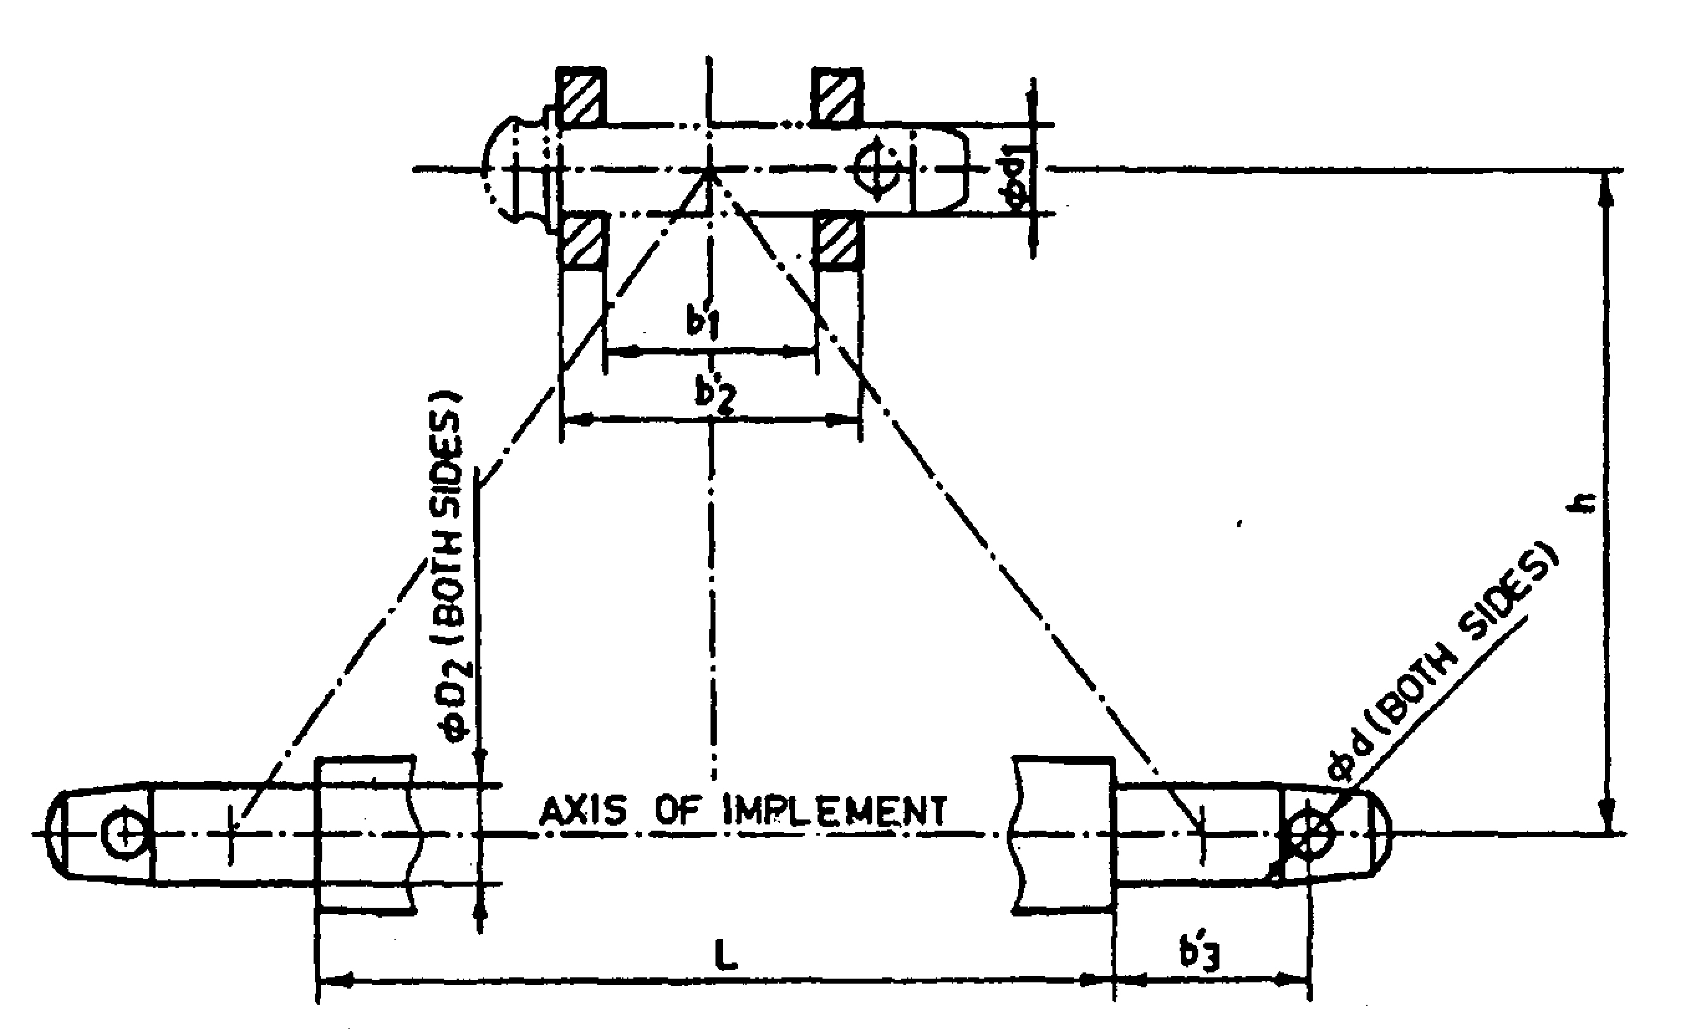
Fig. 1 : Implement Hitch Attachment

2.11 | Arrangement of transport | :

3 |  | Overall dimensions (mm) :
 |  | a) | Length | :
 |  | b) | Width | :
 |  | c) | Height | :
 |  | d) | Mass, (kg) | :
4 | Color of implement |  |  | :
5 | Material used

Sr. | Name of components | Material
1 | Frame
2 | Gang axle
3 | Spool
4 | Scraper
5 | Gang angling mechanism
6 | Transport wheel
7 | Loading platform , if provided
8 | Draw bar /hitch
9 | Gang bearing
10 | Hitch pin
11 | Discs

Place:
Date:
Signature : _________________________

Name : _________________________

Designation: ________________________

